Trinity United Methodist Church

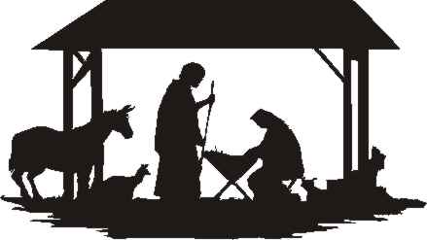

**Christmas Eve 2021**

**Prelude**

**Welcome**

**\*Call to Worship**

Emmanuel: God, you are with us.

**We have heard the promise of the prophets;**

We have caught the notes of the angel’s song;

**We have seen a star in the heavens, we have believed.**

Tonight we have come to be with you because you have come to be with us.

**We seek an innocent, helpless baby in a crude manger;**

we seek a messiah who will reign with justice;

**and you, who are the weakest and the strongest,**

**the most humble and the most mighty have found us.**

Now we may find ourselves.

**Now we may love each other, now we may truly**

**worship you. Crying aloud with the heavenly host:**

**“Glory to God in the highest! Peace on earth and**

**Goodwill to all people” Amen.**

**Hymn**  *O Come, All Ye Faithful (1-4*) No. 234

*Hark! The Herald Angels Sing* No. 240

**Lighting the Advent Wreath**

Tonight is the night for which we have been waiting. The Advent wreath is completed with the Christ candle in the center. With the birth of Christ our lives are centered, focused, turned toward God. We light this candle because Christ is the center our lives.

**Dear God, who comes to us in Jesus, on this night**

**as we celebrate the birth of your Son, let the power**

**of Christ come into our hearts that we might find**

**peace with you forever. Amen.**

**First Lesson Luke 1:26-35**

**Carol O Little Town of Bethlehem No. 230**

**Second Lesson Luke 1:46-55**

**Carol O Come, O Come Emmanuel (1, 2, 6, 7) No. 211**

**Third Lesson Luke 2:1-7**

**Carol What Child Is This No. 219**

**Fourth Lesson Luke 2:8-14**

**Carol Away in a Manger No. 217**

**Fifth Lesson Luke 2:15-20**

**Carol Joy to the World No. 246**

**Sixth Lesson John 1:1-5, 9-14**

**Special Music Mary Did You Know Jessica Wells**

**Come to the Manger Pastor Tom**

**Communion**

**\* Carol, Silent Night No. 239**

**\* Benediction**

Merry Christmas!